# CS 255 System Design Document Template

Bobby Rust

August 14, 2023

## UML Diagrams

### UML Use Case Diagram

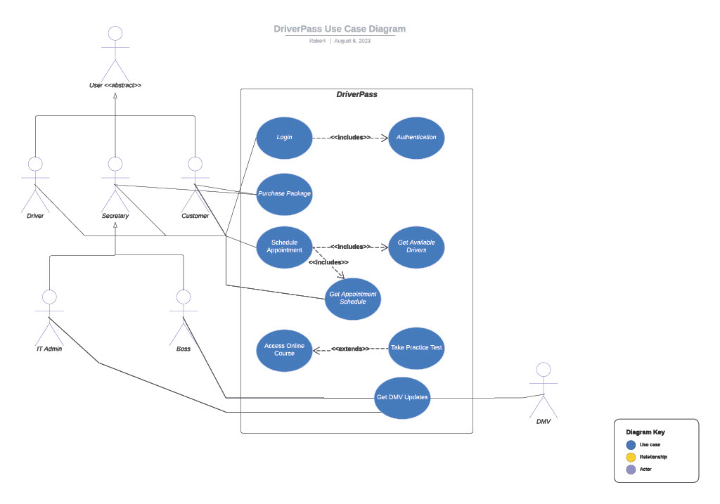

### UML Class Diagram

## Technical Requirements

* The clients must have access to computer hardware that runs any modern web browser.
* The server does not need hardware as it will utilize cloud technologies that provide higher scalability, reduced maintenance, load-balancing, and reduced cost. It will throttle server resources during low load times and increase server resources to account for increased load, ensuring that no unneeded cost is spent on server resources.
* Linux or Windows may be selected for the servers running on the cloud. Windows would offer less maintenance, but Linux has higher customizability and security features. It is a trade-off.
* To reduce system administration efforts, the system should consider utilizing security-as-a-service technologies.
* The backend will require a database, likely any SQL-based database will do such as PostgreSQL.
* The backend should be built with a backend framework to minimize development efforts, such as Node.js which has a wide selection of packages and a robust package manager, Node Package Manager (NPM). Java or similar is also suitable depending on the expertise of the development team.
* The front end may also utilize a framework such as React to streamline the development of the application.